Q1)

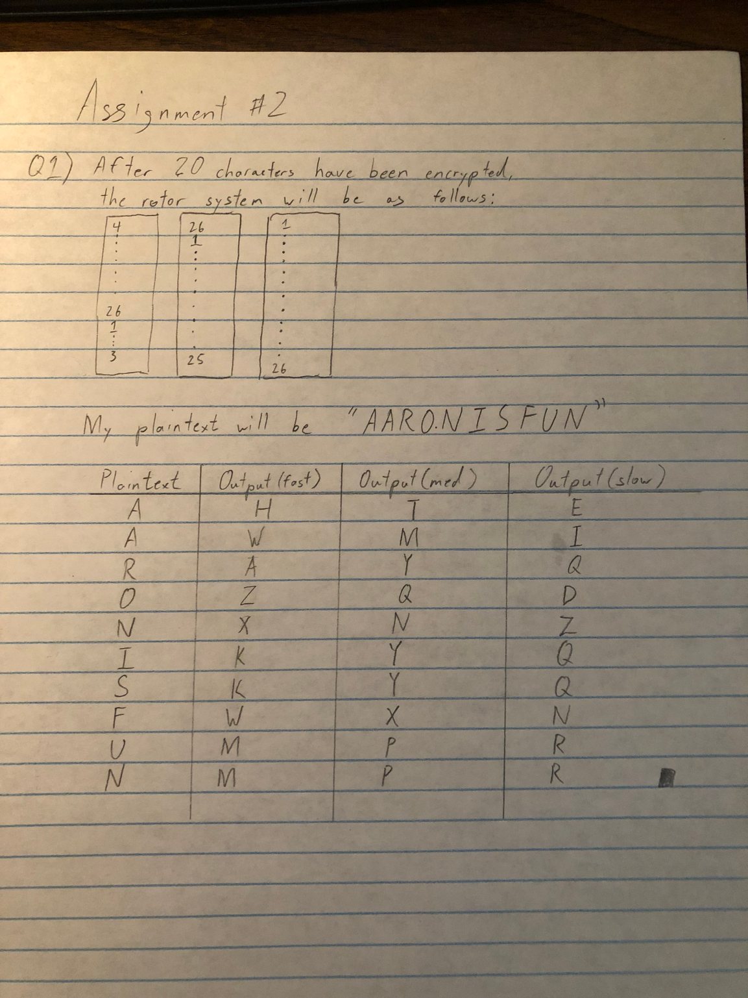

Q2)

The following was my 4-bit s-box

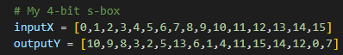

A difference distribution table was created from the s-box.

Refer to difference_distribution_table.py for code.

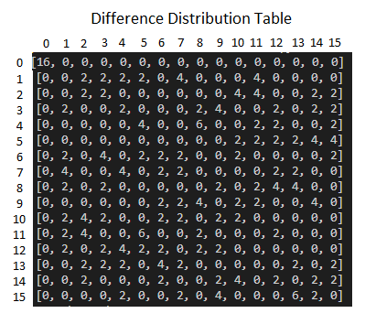

The best differential characteristic was made using data from the difference distribution table.

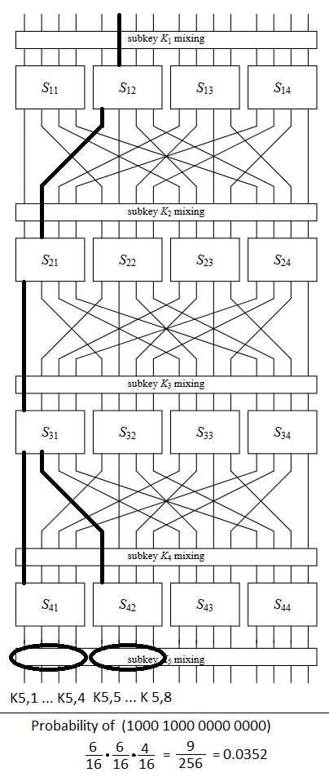

Then, I generated 10,000 16-bit plaintext and encrypted them. Details of the code can be found in Encryption.py. The plaintext-ciphertext pairs can be found in pc-pairs.txt

I proceeded to attempt a differential cryptoanalysis attack. Details of code can be found in Differential_Attack.py. The results of the attack are shown in the frequency table below.

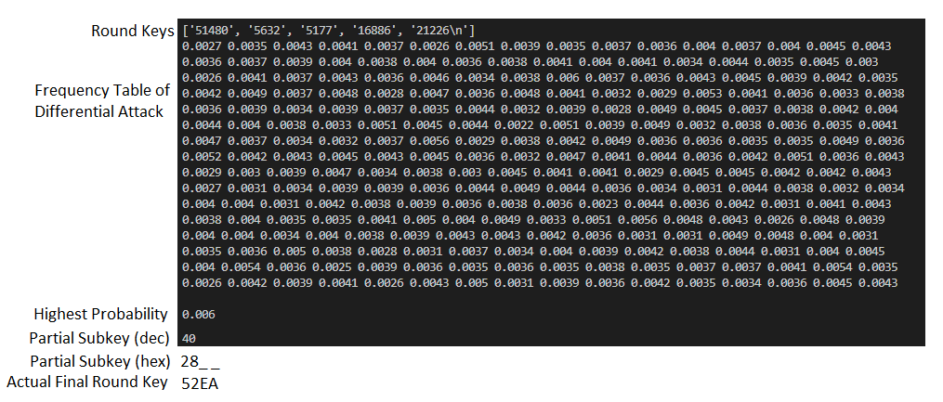

I was unable to find any partial subkey with noticeably high probability. I suspect I may have incorrectly implemented counting the frequency for the differential attack.

Since I worked alone, I “switched” Person1 and Person2 by generating a different set of round keys

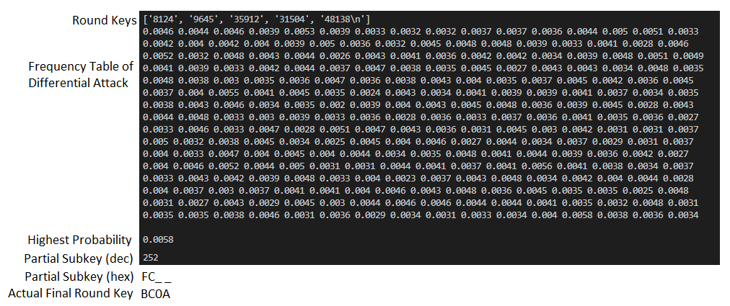

Again I was unable to find any partial subkey with significant high probability, hence why the guess for the partial subkey was incorrect.

Q3)

